HAN22080311

**Character and Enemy Design for an Action Game**

**Character Design for Relic Hunters Zero: Remix**

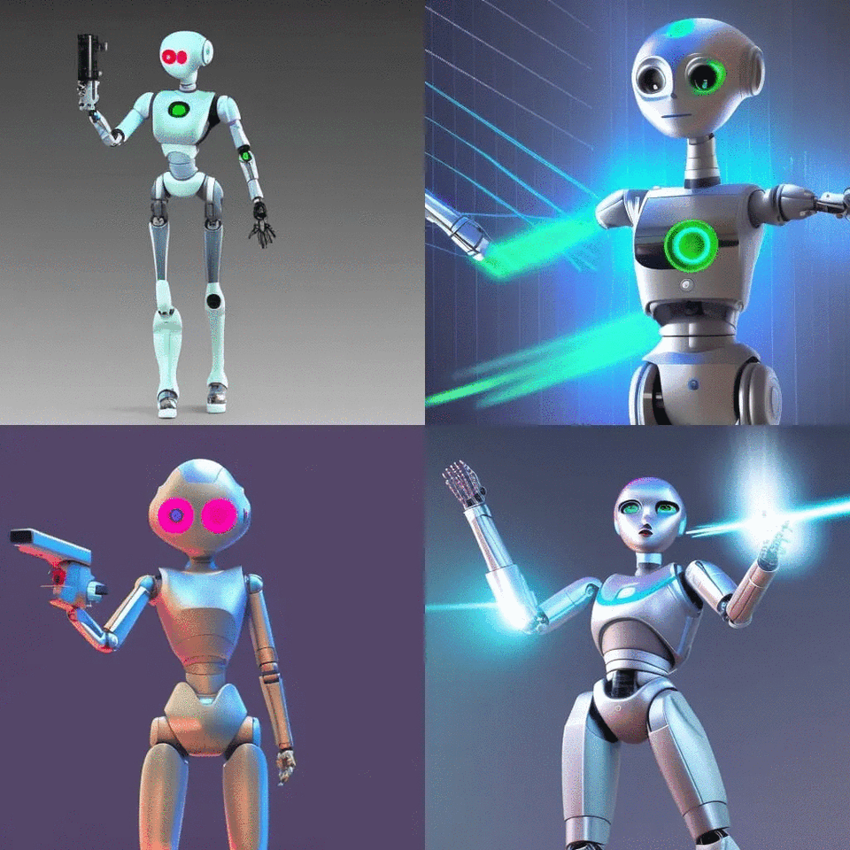

Created by AI.

Relic Hunters Zero: Remix Nita's 8th player is a female cyborg character. She was created by the powerful Relics in Asteroid. Nita was found when SpaceHeart, a crew of relic hunters, explored the Asteroid. Nita will have unique skills and abilities as a robot, unlike other Relic hunters.

Nita's appearance is quite glossy because she is covered with metal. Nita is a robot, so the character design will look to the future, with a modern skill that can teleport within about 20m of the location, helping her avoid enemy attacks. Nita's body contains the necessary tools for combat; not a single detail is superfluous. Nita's eyes have infrared and ultraviolet rays to detect clues, traces, and hidden traps... Nita can attack both far and near, especially far on the hand. She is equipped with a laser gun that can penetrate any material. This gun was released from his hand when Nita pressed a series of parameters on his chest. Nita has a tiny shield when worn on her back, but just taking it out can shield all 8 other Relic hunters.

Character design and a series of optimized weapons on the body will bring quite a challenge when players choose this character. Robo in the future world is always an attractive choice for players who want to transform into their favorite fictional character to explore and defeat enemies. The character's target audience is fans of sci-fi and futuristic games and competitive players who want to master Nita's strategies and skills.

**Enemy Designs for Iron Snout**

Art Station

The first enemy in Iron Snout is a wolf with a fuse on its head. It can be considered a wolf bomb. When it determines an opposition ahead, the bomb wolf will rush forward, block the player from moving forward or backward, and set a time of 3 seconds from activation to explosion. Bomb wolves move and place bombs very quickly, requiring players to move forward or backward quickly, avoiding the bomb as much as possible. Because the wolf bomb is set up to run fast, its explosion area is relatively weak and small. Players need quick hands and quick eyes to be able to defeat and dodge their attacks. This will be an easy enemy to defeat, easy to hit.

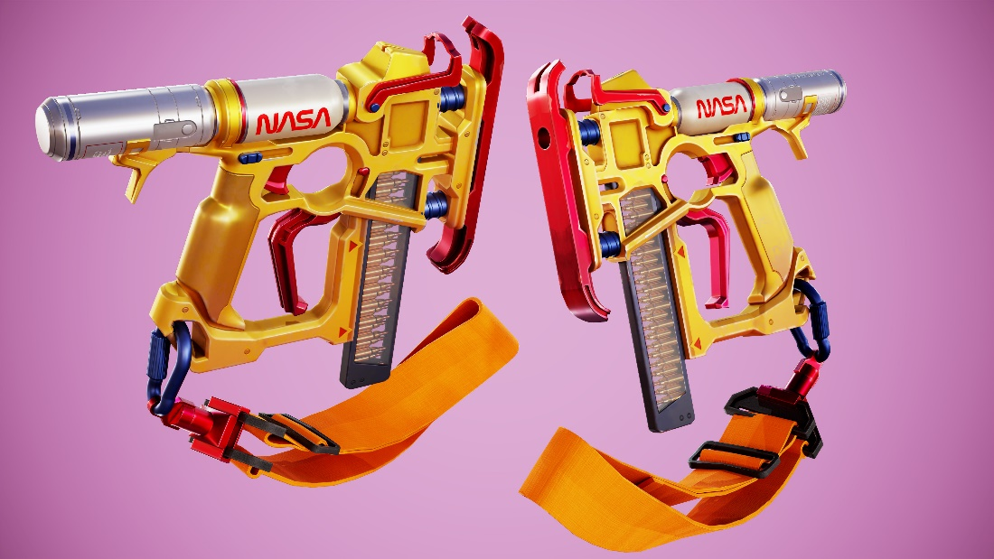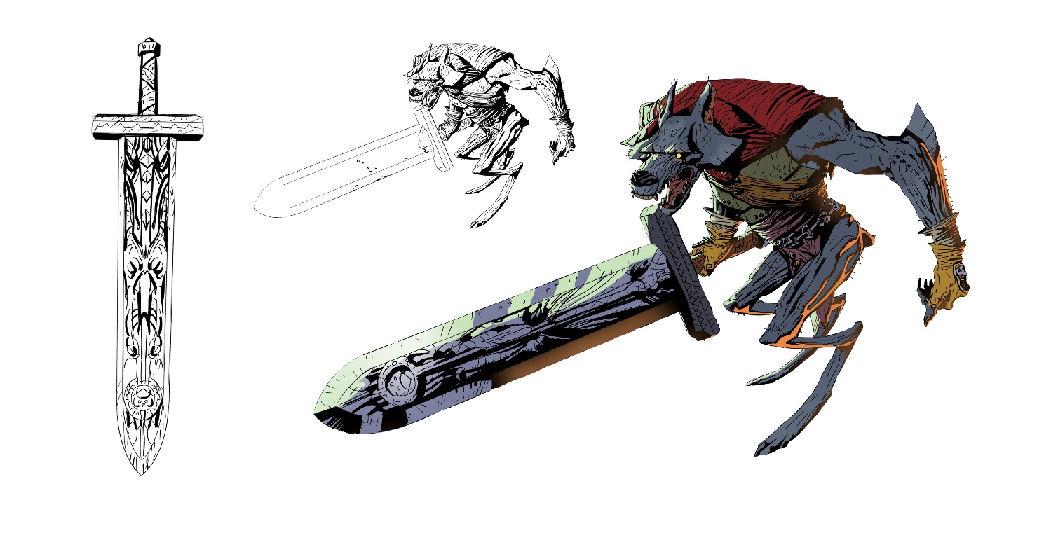

Art Station

The second enemy will be the boss. It's a wolf with a nail gun. This one will be harder to beat than the bomb wolf. For a specific time, when the spiked rooster identifies an enemy within its range, it will face the sky and shoot the nail. These nails will fall from the sky to where the character is standing. It is also challenging for players to approach the nail wolf because, just entering its area, it will pull out a gun to shoot. The range of this wolf is vast. Even if the player moves continuously, the nails with enormous damage will continue to move and attack. Not only that, but the nail wolf also can avoid the player's attacks. It is challenging to kill it. With this enemy, the game requires the player to attack the nail wolf quickly, so it does not have time to pull out the gun to shoot.

These two enemies give Iron Snout a variety of gameplay and flexibility, challenging players in new ways. Gamers often want to challenge their skill, along with character and graphic design that suit children and teenagers.

Word count: 590 words

**Reference list**

NightCafe Creator. (n.d.). *Create Something Amazing*. [online] Available at: <https://creator.nightcafe.studio/studio?open=creation&panelContext=%28jobId%3A3IXvIVSksXF2VM09i87h%29>

Relic Hunters Wiki. (n.d.). *Relic Hunters Zero*. [online] Available at:

<https://relic-hunters-series.fandom.com/wiki/Relic_Hunters_Zero#Characters>

Iron Snout Wikia. (n.d.). *Enemies*. [online] Available at: <https://ironsnout.fandom.com/wiki/Category:Enemies>

Steam (2015). *Relic Hunters Zero: Remix on Steam*. [online] Available at: <https://store.steampowered.com/app/382490/Relic_Hunters_Zero_Remix/>

Steam (2016). *Iron Snout on Steam*. [online] Available at: <https://store.steampowered.com/app/424280/Iron_Snout/>